Measurement Protocol PAX

# General Information:

|  |  |  |
| --- | --- | --- |
| Test date: 09/12/19 | Date prev. test: NA | Test number: 1 |
| Tested by: Alex Pollak | PAX number: PB-038 | Installed at ant.: NA |
| Comments: X-Pol Power sweep response not ideal | | |
|  | | |
|  | | |
|  | | |
| Known problems: | | |
| LNA biasing is jumping by 5mA / also no consistency between detector calibrations! | | |
| For now considered faulty | | |
|  | | |

# Setup:

|  |  |  |  |
| --- | --- | --- | --- |
| Power supply: | OK 🗹 NOK 🗆 | Communication: | OK 🗹 NOK 🗆 |
| Supply current +6V: 1.106mA | | ssh obs@antcntl | |
| Supply current -6V: 0.121mA | | ssh ataant@ant0 | pw: q@n@t |
| Supply current +5V: 0.062mA | | telnet pax | “help” |
|  | | CTRL + ] | “close” |

# RF Test with VNA:

### VNA Setup:

|  |  |  |
| --- | --- | --- |
| Load configuration: Passband_PAX.csa | | |
| Freq Start: 1.0 GHz | Freq Stop: 13.0 GHz | Power Level: -20 dBm |
| Averaging: enabled | Averaging count: 15 | N. Points: 801 |
| VNA : Agilent N5230C 10MHz - 20GHz | | |

|  |  |  |  |  |
| --- | --- | --- | --- | --- |
| VNA to PAX connection: | 1m ABC-CA18 Cable + 20dB Attenuator | | | |
| Input Power Level to PAX: (Measured) | @1GHz:  -40.2dBm | @4GHz:  -40.7dBm | @8GHz: -41.2dBm | @12GHz: -41.4dBm |

|  |  |
| --- | --- |
| PAX to VNA connection: | 2m Fibre Cable + Fibre Diode + AOX Amplifier + 1m ABC-CA18 Cable |

### Measured Passband with Attenuator set to 7dB each (Complete Link):

|  |
| --- |
| X |

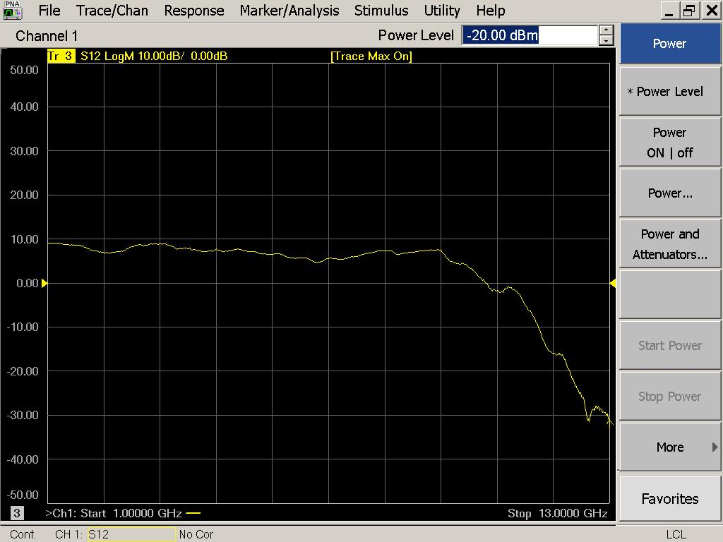

|  |  |  |  |
| --- | --- | --- | --- |
| Flatness: | OK 🗹 NOK 🗆 | Unwanted Features: | Yes 🗆 No 🗹 |

|  |
| --- |
| Y |

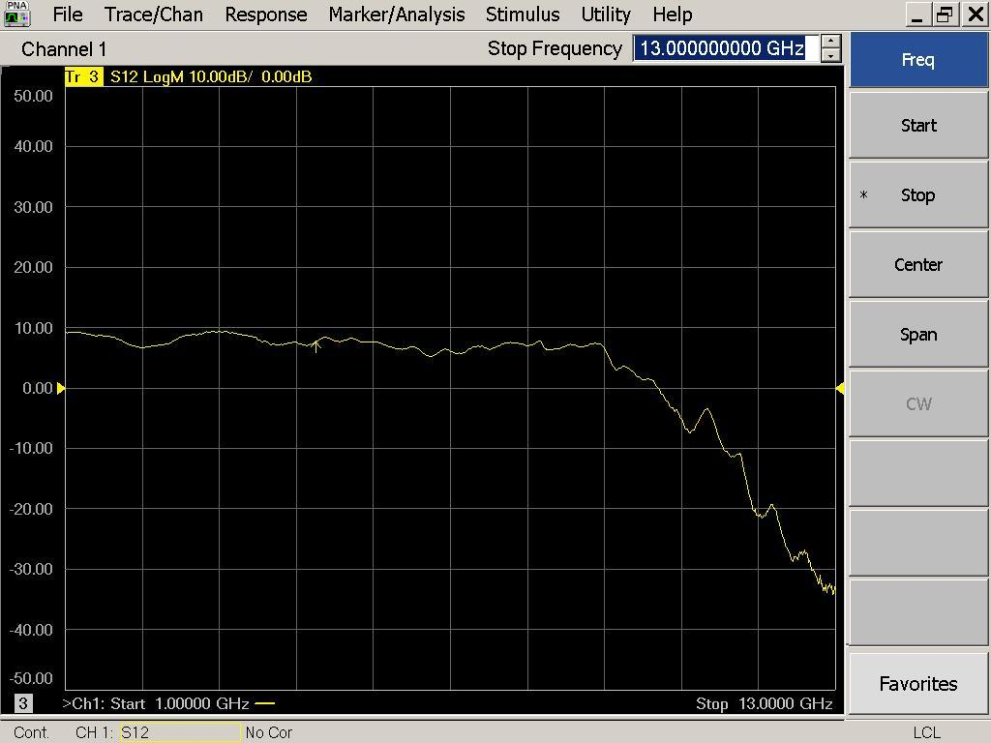

|  |  |  |  |
| --- | --- | --- | --- |
| Flatness: | OK 🗹 NOK 🗆 | Unwanted Features: | Yes 🗆 No 🗹 |

### Power Sweep (Complete Link):

|  |  |  |
| --- | --- | --- |
| Load configuration: Power_Sweep_PAX.csa | | |
| Power Start: -40dBm | Power Stop: -20dBm | Frequency : 4.0GHz |
| PAM Attenuator: 0dB |  | N. Points: 801 |

|  |
| --- |
| X |

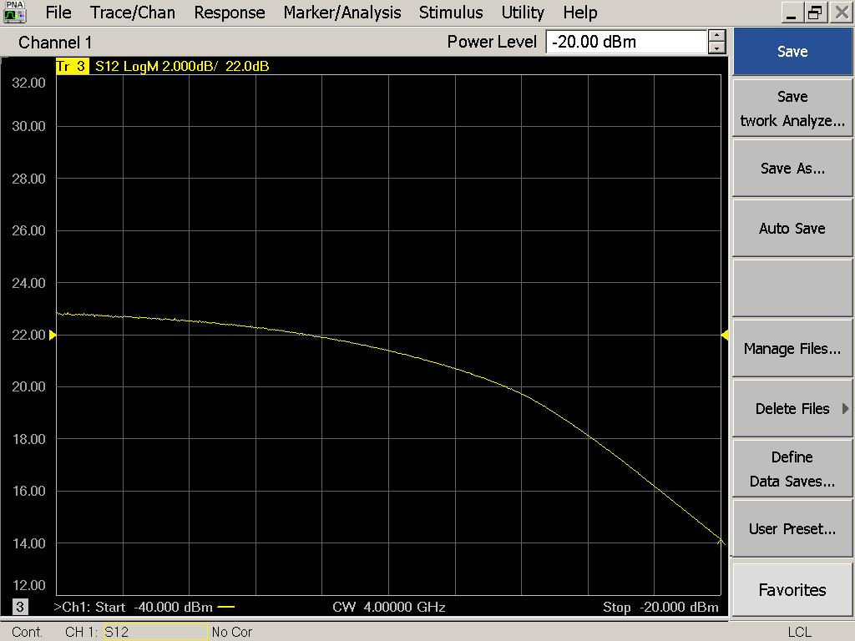

|  |  |  |  |
| --- | --- | --- | --- |
| Compression point: | OK 🗹 NOK 🗆 | Unwanted Features: | Yes 🗆 No 🗹 |

|  |
| --- |
| Y |

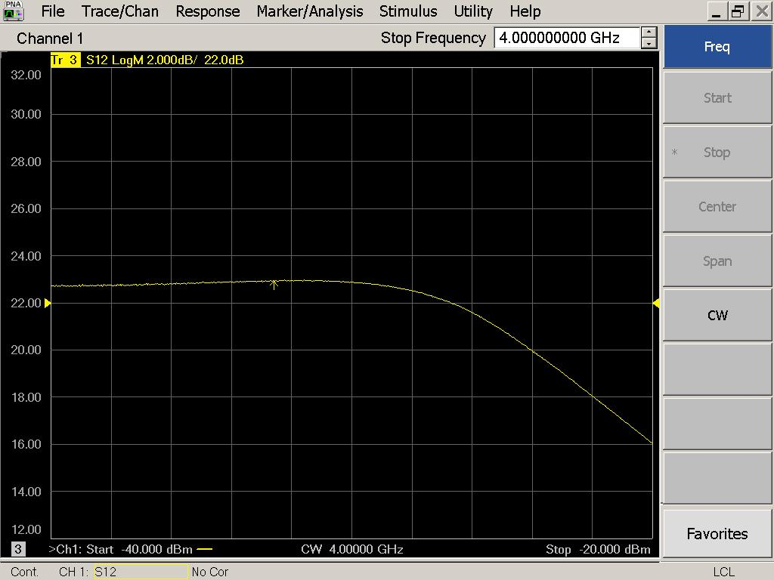

|  |  |  |  |
| --- | --- | --- | --- |
| Compression point: | OK 🗹 NOK 🗆 | Unwanted Features: | Yes 🗆 No 🗹 |

### Detector Calibration and Attenuator Sweep Pol X:

|  |  |  |
| --- | --- | --- |
| Load configuration: Detector_Calibration_PAX.csa | | |
| Freq : 4.0 GHz | Power Level: -20dBm | Sweep Time: -20sec |
| Sweep Mode: CW | Power Level at PAX Input (Measured): -40.6dBm | |

|  |  |  |  |  |
| --- | --- | --- | --- | --- |
| X | | | | |
| CW Input Power [dBm]: | Attenuator Value A [dB]: | Attenuator Value: B [dB]: | Detector Value: | Power Meter  Value [dBm]: |
| -40.6 | 0 | 0 | - | 14.34 |
| -40.6 | 0 | 3 | - | 14.36 |
| -40.6 | 0 | 6 | - | 13.22 |
| -40.6 | 0 | 9 | 0.8583 | 10.48 |
| -40.6 | 0 | 12 | 0.5574 | 7.40 |
| -40.6 | 0 | 15 | 0.3382 | 4.53 |
| -40.6 | 0 | 18 | 0.1801 | 1.18 |
| -40.6 | 0 | 21 | 0.0985 | -1.93 |
| -40.6 | 3 | 21 | 0.0486 | -5.23 |
| -40.6 | 6 | 21 | 0.0252 | -8.22 |
| -40.6 | 9 | 21 | 0.0135 | -11.16 |
| -40.6 | 12 | 21 | 0.0074 | -14.17 |
| -40.6 | 15 | 21 | 0.0044 | -17.07 |
| -40.6 | 18 | 21 | 0.0026 | -20.50 |
| -40.6 | 21 | 21 | 0.0019 | -23.58 |
| -40.6 | 24 | 21 | 0.0016 | -26.42 |
| -40.6 | 27 | 21 | 0.0014 | -29.45 |
| -40.6 | 30 | 21 | 0.0013 | -32.68 |
| -40.6 | 30 | 24 | 0.0013 | -35.35 |
| -40.6 | 30 | 27 | 0.0012 | -37.89 |
| -40.6 | 30 | 30 | 0.0012 | -40.26 |

|  |  |  |
| --- | --- | --- |
| Use Noise Source: Atlantic AS6333 | | |
| Freq : 1.0 - 12.0GHz | Power Level: -41.8dBm |  |
| DC Supply: 28V |  | |

|  |  |  |  |  |
| --- | --- | --- | --- | --- |
| X | | | | |
| CW Input Power [dBm]: | Attenuator Value A [dB]: | Attenuator Value: B [dB]: | Detector Value: | Power Meter  Value [dBm]: |
| -41.8 | 0 | 0 | - | 12.64 |
| -41.8 | 0 | 3 | - | 11.51 |
| -41.8 | 0 | 6 | - | 9.74 |
| -41.8 | 0 | 9 | - | 7.51 |
| -41.8 | 0 | 12 | 0.8582 | 4.66 |
| -41.8 | 0 | 15 | 0.5854 | 2.02 |
| -41.8 | 0 | 18 | 0.3181 | -1.21 |
| -41.8 | 0 | 21 | 0.1767 | -4.19 |
| -41.8 | 3 | 21 | 0.0957 | -7.18 |
| -41.8 | 6 | 21 | 0.0485 | -10.27 |
| -41.8 | 9 | 21 | 0.0261 | -13.08 |
| -41.8 | 12 | 21 | 0.0135 | -16.11 |
| -41.8 | 15 | 21 | 0.0080 | -18.78 |
| -41.8 | 18 | 21 | 0.0043 | -22.23 |
| -41.8 | 21 | 21 | 0.0028 | -25.34 |
| -41.8 | 24 | 21 | 0.0021 | -28.31 |
| -41.8 | 27 | 21 | 0.0018 | -31.12 |
| -41.8 | 30 | 21 | 0.0015 | -34.47 |
| -41.8 | 30 | 24 | 0.0015 | -37.02 |
| -41.8 | 30 | 27 | 0.0015 | -39.19 |
| -41.8 | 30 | 30 | 0.0015 | -41.23 |

### Detector Calibration and Attenuator Sweep Pol Y:

|  |  |  |
| --- | --- | --- |
| Load configuration: Detector_Calibration_PAX.csa | | |
| Freq : 4.0 GHz | Power Level: -20dBm | Sweep Time: -20sec |
| Sweep Mode: CW | Power Level at PAX Input (Measured): -40.6dBm | |

|  |  |  |  |  |
| --- | --- | --- | --- | --- |
| Y | | | | |
| CW Input Power [dBm]: | Attenuator Value A [dB]: | Attenuator Value: B [dB]: | Detector Value: | Power Meter  Value [dBm]: |
| -40.6 | 0 | 0 | - | 14.16 |
| -40.6 | 0 | 3 | - | 14.19 |
| -40.6 | 0 | 6 | - | 13.35 |
| -40.6 | 0 | 9 | 0.8569 | 10.80 |
| -40.6 | 0 | 12 | 0.5396 | 7.70 |
| -40.6 | 0 | 15 | 0.3261 | 4.85 |
| -40.6 | 0 | 18 | 0.1711 | 1.50 |
| -40.6 | 0 | 21 | 0.0910 | -1.62 |
| -40.6 | 3 | 21 | 0.0439 | -5.03 |
| -40.6 | 6 | 21 | 0.0233 | -7.96 |
| -40.6 | 9 | 21 | 0.0122 | -11.04 |
| -40.6 | 12 | 21 | 0.0069 | -13.97 |
| -40.6 | 15 | 21 | 0.0042 | -16.98 |
| -40.6 | 18 | 21 | 0.0026 | -20.33 |
| -40.6 | 21 | 21 | 0.0020 | -23.39 |
| -40.6 | 24 | 21 | 0.0017 | -26.36 |
| -40.6 | 27 | 21 | 0.0015 | -29.54 |
| -40.6 | 30 | 21 | 0.0015 | -32.76 |
| -40.6 | 30 | 24 | 0.0014 | -35.46 |
| -40.6 | 30 | 27 | 0.0014 | -37.94 |
| -40.6 | 30 | 30 | 0.0014 | -40.28 |

|  |  |  |
| --- | --- | --- |
| Use Noise Source: Atlantic AS6333 | | |
| Freq : 1.0 - 12.0GHz | Power Level: -41.8dBm |  |
| DC Supply: 28V |  | |

|  |  |  |  |  |
| --- | --- | --- | --- | --- |
| Y | | | | |
| CW Input Power [dBm]: | Attenuator Value A [dB]: | Attenuator Value: B [dB]: | Detector Value: | Power Meter  Value [dBm]: |
| -41.8 | 0 | 0 | - | 12.87 |
| -41.8 | 0 | 3 | - | 11.84 |
| -41.8 | 0 | 6 | - | 10.14 |
| -41.8 | 0 | 9 | 0.8568 | 7.99 |
| -41.8 | 0 | 12 | 0.5737 | 5.12 |
| -41.8 | 0 | 15 | 0.3592 | 2.54 |
| -41.8 | 0 | 18 | 0.1882 | -0.67 |
| -41.8 | 0 | 21 | 0.1014 | -3.66 |
| -41.8 | 3 | 21 | 0.0536 | -6.69 |
| -41.8 | 6 | 21 | 0.0277 | -9.73 |
| -41.8 | 9 | 21 | 0.0149 | -12.66 |
| -41.8 | 12 | 21 | 0.0081 | -15.65 |
| -41.8 | 15 | 21 | 0.0051 | -18.35 |
| -41.8 | 18 | 21 | 0.0032 | -21.77 |
| -41.8 | 21 | 21 | 0.0024 | -24.85 |
| -41.8 | 24 | 21 | 0.0020 | -27.95 |
| -41.8 | 27 | 21 | 0.0017 | -30.83 |
| -41.8 | 30 | 21 | 0.0016 | -34.17 |
| -41.8 | 30 | 24 | 0.0016 | -36.76 |
| -41.8 | 30 | 27 | 0.0016 | -38.92 |
| -41.8 | 30 | 30 | 0.0016 | -41.02 |

# LNA Bias Supply:

Note that the bias supply is tested without an LNA connected to the PAX box!

|  |  |
| --- | --- |
| Enable Supply: “lnabiaslatch” | Disable Supply: “lnabiasoff” |

|  |  |  |  |
| --- | --- | --- | --- |
| X | | Y | |
| Vg: | 0.20 | Vg: | -0.03 |
| Vd: | 1.23 | Vd: | 1.23 |
| Vm: | -0.52 | Vm: | -0.52 |
| Id: | 0.1 | Id: | 0.1 |
| Bias Supply: OK 🗹 NOK 🗆 | | Bias Supply: OK **🗹** NOK 🗆 | |

# Inspection:

### Visual:

|  |  |  |
| --- | --- | --- |
| Fibre Connectors Clean | Comments: | OK 🗹 NOK 🗆 |
| Fibre Connector Mechanical | Comments: | OK **🗹** NOK **🗆** |
| RF Cable | Comments: | OK **🗹** NOK **🗆** |
| RF Connectors Clean | Comments: | OK **🗹** NOK **🗆** |
| RF Connector on PAM screws tight | Comments: Was not tight when inspected | OK **🗹** NOK **🗆** |

### Functions:

|  |  |  |
| --- | --- | --- |
| Read Temperature Value | Comments: 31.6 | OK 🗹 NOK 🗆 |
| LNA Settings | Comments: | OK 🗆 NOK **🗆** |
| Temperature Stabilisation | Comments: | OK 🗆 NOK **🗆** |
| Software Version: | Date: 2007/11/15 18:00:00 Revision: 1.10 pax controller | OK **🗹** NOK **🗆** |